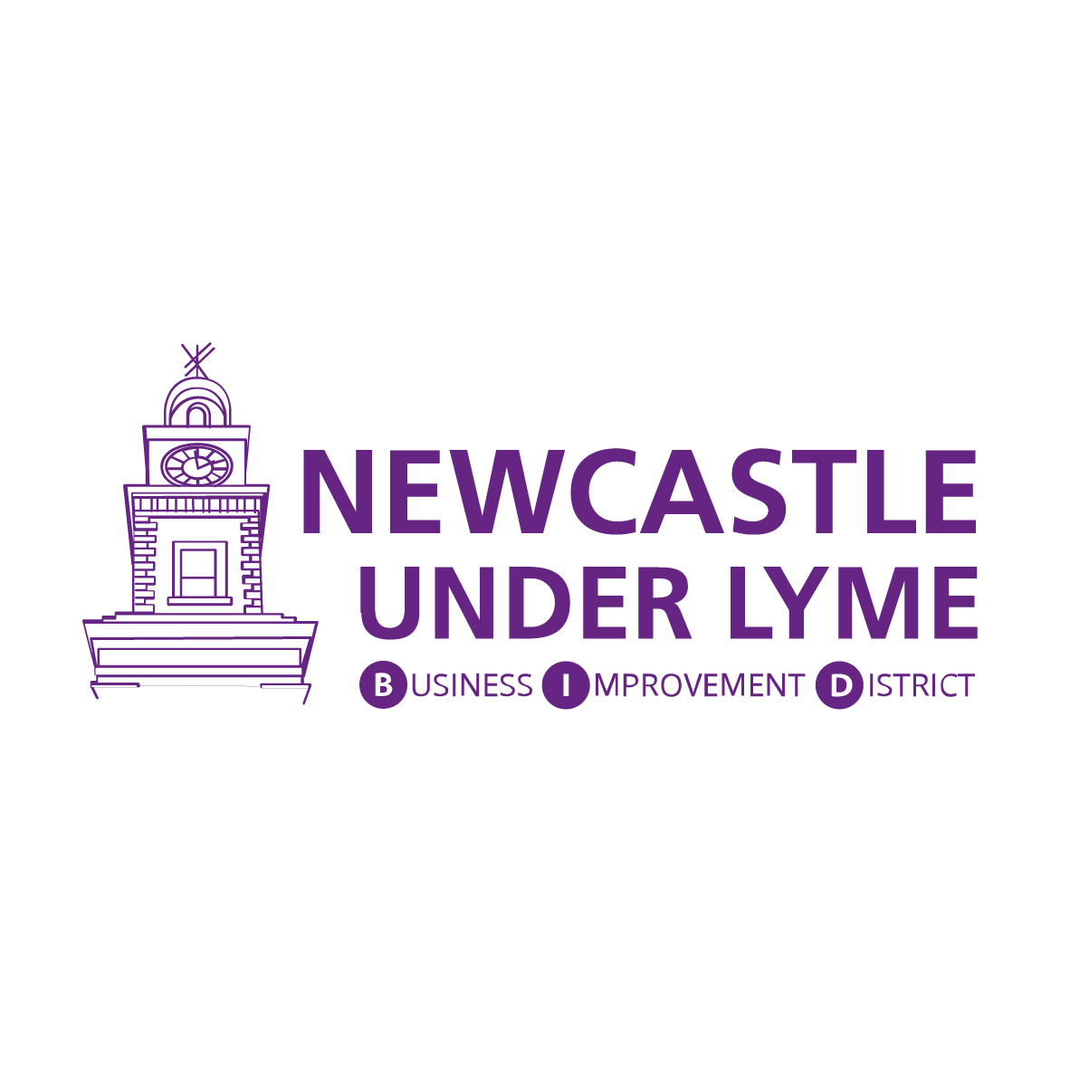

Newcastle-under-Lyme BID Shop Front Improvement Scheme
Please read Shop Front Improvement Scheme Guidance Notes before completing this application.
Please note: a levy paying business will only be eligible if their levy payments are up to date.
Non levy businesses can become Voluntary BID member to qualify for the grant. For more information on how to become by emailing hello@nulbid.co.uk for more information.
- Application Details
Applicant Name
Business Name
Applicant Address
Applicant Email
Applicant’s Phone No
Business Website
Business address for which you are applying for a grant
(If different from above)
I am - | ☐ Building Owner ☐ Tenant
If you are a tenant, do you have the property owner’s permissions for this work? | ☐ Yes ☐No
Are you a BID levy paying business? | ☐ Yes ☐No (RTV below £12,001)

2. Improvement Details:
Please describe the changes that you propose to make including:

• Whether you are changing doors, windows or entrances
• What changes you want to make to the building’s frontage, including details of features you want to add or remove
• Details of colours and style you will use

When do you propose to start the works?
How long are the works expected to take?
Did you speak to Newcastle-under-Lyme Borough Council to establish a need for Planning Permission/ Listed Building Consent/ Conservation Area Consent and/or Advertisement Consent? (It is required that each applicant does so.) | ☐ Yes ☐No  ☐ I confirm that NO consent is needed  ☐ I enclose a copy of consent  ☐ I will apply upon receiving a provisional grant offer
- Estimated Costs:
Please list the items of work proposed and their estimated costs:
 | Estimated Cost
 | £
 | £
 | £
 | £
 | £
Total | £
Please give details of how you have established the project costs.

Did you obtain more than one quotation? ☐ Yes ☐No

Is your finance for the project in place? ☐ Yes ☐No

4 . Applicant Declaration:
I hereby declare that I have read the terms and conditions and declare that the information given within this application form and in any supporting material is correct to the best of my knowledge.

I understand that if I give any misleading statements, whether intentional or accidental, at any stage during the application process, or knowingly withhold any material information, my application could be invalid and I may have to repay any grant.

I have read and understood the criteria for this grant.

I will notify Newcastle-under-Lyme BID of any changes to the details of this application and in particular the award of any further funding from other sources.

Print name: _________________________

Position: ____________________________
Signature: ___________________________ Date: _______/_______/_______
Application must be signed in the case of a limited company by a director, otherwise by a proprietor or partner.

If you are not the property owner, the application must be signed in support by the property owner.

I confirm that I am the property owner of _______________________________________________ and I agree to the current leaseholder using a Newcastle-under-Lyme BID Shop Front Improvement Grant to improve the frontage of the property.

Print name: _________________________
Signature: ___________________________ Date: _______/_______/_______

- Applicant Checklist :
As well as this form, you need to provide:
- A copy of the lease agreement (if applicable) ☐
- Copies of any statutory consent notifications (e.g. planning permission if req) ☐
- Photographs showing your current shop front ☐
- Sketches or design proposals showing the proposed improvement ☐
- Quotations for improvements ☐

Please return the completed form via e-mail with all the supporting documents to hello@nulbid.co.uk or via post to Newcastle-under-Lyme BID, The Guildhall, High Street, Newcastle-under-Lyme, ST5 1PW.
Applications will be considered by a panel of the Newcastle-under-Lyme BID Board of Directors. All grant offers will be made in writing within 3 weeks of receiving your application.
Applications for funding must be made by 30th September 2023, with improvements being completed within six months of approval.

